DARTECH AND WILMINGTONIAN

A NEWSLETTER FROM YOUR OLD SCHOOL

IN MEMORY OF

JAMES ARTHUR AUSTEN, ‘SAM’ (Staff - 1954-1974)

Dear Member
I regret that we have to advise you that our great friend and former member of Staff, Jim ‘Sam’ Austen has passed away
His funeral is on Monday 28th November, at 1230, at The Hastings Cemetery, The Ridge:
https://www.google.co.uk/maps/place/Hastings+Crematorium/@50.8808343,0.590895,15z/data=!4m5!3m4!1s0x0:0xf4961acc2103bf21!8m2!3d50.8808343!4d0.590895
Should you wish to pay your last respects to ‘Sam’ and attend the Funeral you will be welcome, especially as to the best of our knowledge he had no other family to mourn him. We would appreciate it if you could let me know before next Thursday 25th November so that we can contact his neighbour, who is making the arrangements, and advise her of an approximate number attending.
Regards Dennis Wells (Chairman O.D. & W.A.)
(Since this notice was sent out we have been advised that Sam had a Son Alan, and a Step-Daughter Jacky)

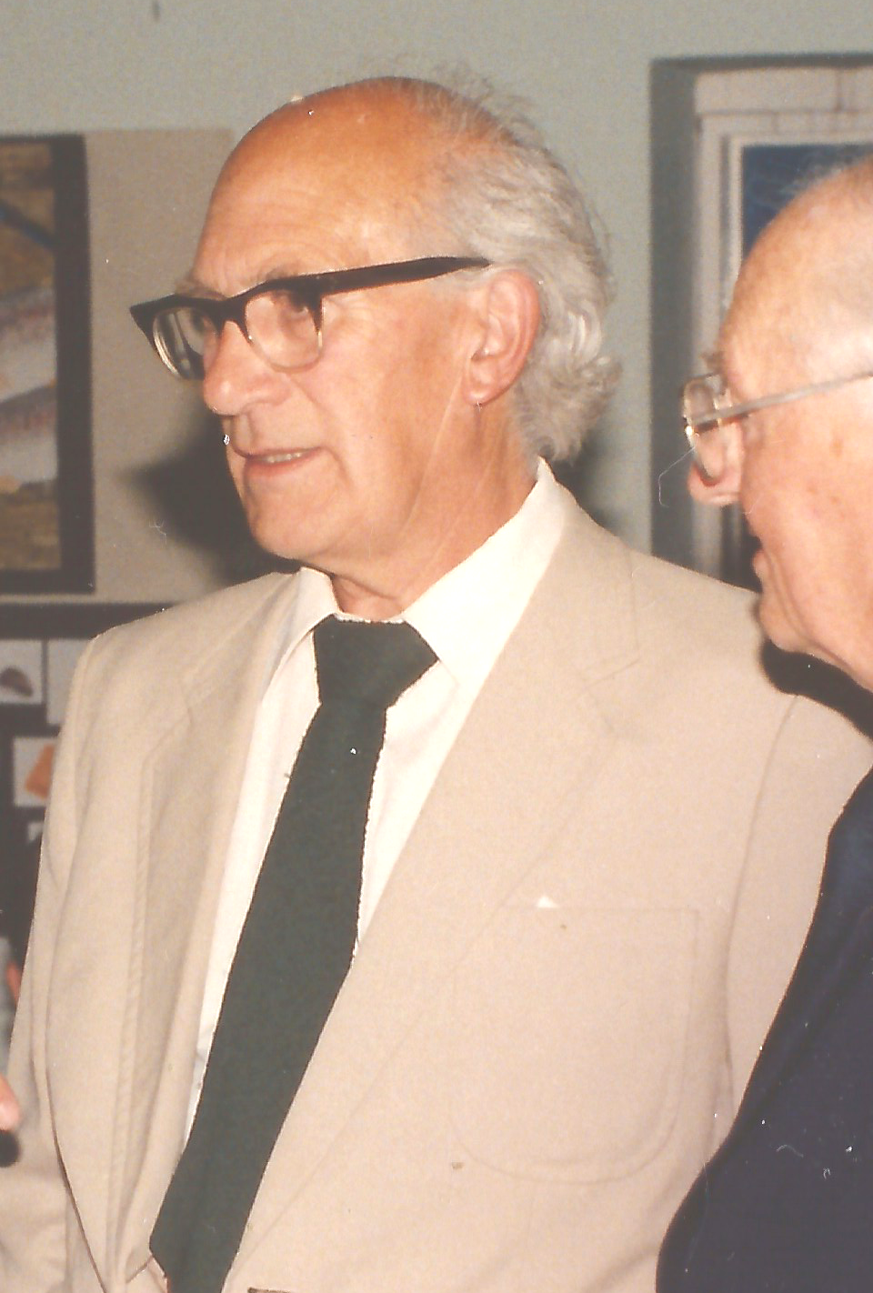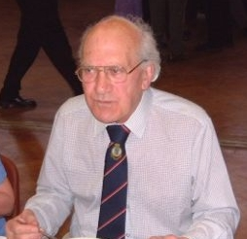
Sam was born on 2nd March 1924 and passed away on 11th November 2016. He came to us as a Engineering Drawing Teacher in 1954, later adding Careers Master to his duties and left for a School in Essex in 1974 as a Careers Master. He managed to get retirement on full pension while in his early fifties and went to live in Hastings where he became involved as a chief examiner for one of the exam boards.
He was married to Lucy in 1945 and had a son Alan, and was married a second time in 1979 to Margaret who already had a Daughter Jacky.

Eight Old Boys were able to attend his Funeral at Hastings on 28th November, during which his Step-Daughter Jacky read the following two poems:

Not how did he die, but how did he live?
Not what did he gain, but what did he give?
These are the units to measure the worth
Of a man as a man, regardless of birth.
Not, what was his church, nor what was his creed?
But had he befriended those really in need?
Was he ever ready, with word of good cheer,
To bring back a smile, to banish a tear?
Not what the sketch in the newspaper did say,
But how many were sorry when he passed away.

Think of me as one at rest
For me you should not weep
I have no pain, no troubled thoughts for I am just asleep
Those of you who liked me I sincerely thank you all
And those of you who loved me I thank you most of all
As time went rushing by I found some time to hesitate, to laugh, to love, to cry
It matters not if time began, if time will ever cease
I was here, I used it all and now I am at peace.

To answer a number of questions I have received I understand that he got the nick-name of ‘Sam’, as a reference to a General Samuel Austen, of American and that he was given it by another dear old friend of ours Percy Black.

A number of amusing comments were made during the Celebrants address, but one that stood out in most of our minds was that Sam used to help Students with lessons on the Guitar, and after one such lesson he advised the recipricant that he would never get anywhere in the music industry, needless to say his name was “Keith Richards”.
Letter to Celebrant Jonathan Mendenhall, who took Sam’s Service
We expect there to be some 8 old boys from Dartford Tech at the event on Monday.
At least those are the ones that have let us know they are likely to come. They are from the years 1954-69.
I think the fact that we expect this number, from that range of dates, to attend after all this time, speaks volumes.
Regret I don’t have any light anecdotes for you.
But this is how I saw him - as I think did most of the Dartford Tech folks that I have known.
Jim was universally known over the years as ‘Sam’ at Dartford Tech.
I don’t think he knew why - nor did anybody else - lost in the mists of time.
He was almost universally regarded with great affection.
He was one of the 2 or 3 staff at DTS who were not continually ragged.
He was always treated with respect.
That was because he was admired - not because we were afraid of him.
I understand he had learned his craft in the hard school.
He told me once that he taught ‘Bevin Boys’ - who were to be sent down the coal mines instead of doing National Service.
They would sit at their benches with their overcoats on, their lunch boxes in front of them and spent all their time trying to disrupt lessons by, for instance, setting light to the underside of the benches with their cigarette lighters.
I guess you learn how to teach in circumstances such as those.
He was firm - but he treated us with respect too.
He was a man of some stature, substance and presence.
He dressed with style.
He always wore a light coloured linen jacket when taking classes in the Drawing Office.
The DO was on the upper floor of what was originally the stable block of Wilmington Hall.
It was set up, and run, just as a proper DO in the outside world.
It was a highly professional operation.
His engineering and geometrical drawings - produced in front of us - in chalk on a series of blackboards - were brilliant, beautiful.
His lettering was likewise immaculate.
I think many of us have striven to reproduce the quality of his work over our working lifetimes - and indeed still strive to do so.
My style of hand printed lettering is still his.
He smoked a curved pipe.
He always tied his tie with a Double Windsor - not very popular then.
Many of us copied him - I still tie my tie that way.
He had a Citroen Light 15 - a very stylish car - at a time when there were very few, if any foreign cars around.
I was very fortunate in being able to connect up with him in later life - through the DTS Old Boy organisation.
He regularly attended the annual Old Boys dinners until latterly that became too difficult for him.
We had many common interests and met up several times over recent years.
We were particularly interested in the industrial archaeology of London.
Not long ago we went to visit the Crossness Pumping Station at Abbey Wood to see their 4 massive beam engines with their 40 ton beams.
He had a fantastic influence on my life.
I am profoundly grateful to have been taught by him.
And to have known him in later life and been able to thank him.
Look forward to meeting you on Monday - (Robin Pitman 1956-63)

RESPONSES RECEIVED FROM ASSOCIATION MEMBERS:-

Good memories of”Sam”, another good one passed on (Clive Jay 1955-59)

Thank you for that information.
I would like to attend but in my current condition can’t get there under my own steam. If you hear from another old boy that they have space in their car could you let me know please. (Chris Portwine 1957-65)

Sad news he seems on his own; he taught technical drawing in the 1960s as I recall is that right ? What a gift he gave me if so. (John Bristow 1960-67)

I am so saddened to hear about the passing of Sam Austen. He really was one of the great characters in my day, a great character in a staff of great people, Wall, Percy Black, Amos, Gregory and Lewis not forgetting the one and only Potter.
The staff in those days inculcated to us a lot more than just academics, giving us a sense of right and wrong, honour and integrity and a desire to achieve. (Ken Howton 1955-61)

I am very sorry to hear of “Sam”’s passing. I counted him among my favourite teachers, a sympathetic and likeable man who infused me with enthusiasm for tech drawing. I regret I won’t be able to be at his funeral, given the distance away but shall remember him in my thoughts. (Trevor Rigg 1957-62)

Hi Dennis, that’s very sad news indeed, he was one of the good guys, did meet him after I left I actually played cricket with him on one occasion, I am afraid as I live some distance away I wouldn’t be attending the funeral
Regards (David Rose 1954-59)

Thanks for the notice, won’t be able to attend, but will remember him and recall the satisfaction I had in bowling him a ‘dolly” and watching him hit it through the top floor classroom window. of the New Building.
Six for Sam. Regards, (Terry Staples 1956-61)
As I have a business appointment at St. James’s at 2.15 on the 28th, I am sorry that I am unable to attend the funeral. Kind regards, (Derek Ford 1951- )

Thank you Dennis, very sorry to hear Sam has gone. Afraid I will not be able to attend.
Best regards, (David Fricker 1967-74)

Sad news indeed. I remember him fondly, and some of what he taught me that I still use.
I have often wondered if Mr Gough is still around. He was a wartime pilot who shared some of his experiences with me as I was always exceptionally enthusiastic about aircraft. I still have some wartime pilots notes he gave me. I have recently obtained one of his combat reports and photos of him with his sqn. I lost touch when I left school in 1977. I got my first Pilot Licence in 1983 and still fly. I got my woodwork O-Level in 1975 and still do woodwork.
If he is still around I would love to contact him and reintroduce him to flying. For me, Mr Gough was the most inspirational teacher so anything you can tell me about him would be gratefully received.
Many thanks. (Martin Radford 1970 - 77)

What sad news. I’m in Edinburgh. Will try change plan for the day and to get early plane. Will let you know by Thursday morning. Regards
Dennis. Easyjet willing, I shall be at funeral next Monday
Where did he live in Hastings? We have a house near Rye. Seems very sad to think that he was not far away
(Christopher Lee 1954-57)

Many thanks for letting me know of Sam’s passing. If I was in the UK I would go to the funeral but as I’m not I won’t be able to.
One of my Dartford compatriots thought that Sam had a wife and children while we were at the school, although I don’t remember them. Do you know if he did? Regards, (Dave Catchpole 1957-64)

A very sad message to receive that Mr Austen has no family to mourn him at his passing, I hope he has friends to attend his funeral to help him on his way. I have a strange affection for the man who I remember trying his best to teach me technical drawing, isometric projections, plans and all that other technical stuff and the fact that he remembered me at the reunion dinner which we attended. At least some of it went in as I have just finished drawing up plans for a spare room which is now under construction and actually used my compass set which my Dad bought for my Dar-Tech experience for the drawings, all very strange as I didn’t do too well at the end of my time there but what knowledge I gained has served me very well throughout my life and which I am still drawing on.
He did his best for all of us and I wish I could be there in Hastings to say goodbye so I’ll just say it from here in West Australia, “VALE Jim (Sam) Austen”. Kind regards (Rod Cronin 1955-1960)

That’s really sad that Mr Austin has no family. He was a good teacher. Regards (Nick Moon 1973-78)

Thank you for letting me know about the sad news that Jim has passed away.
Myself, as a young teacher at Dartford Tech, he was a good role model and I much appreciated his support and good advice. Later, when I got married, my wife and I moved into Baldwins Park close to his house. He and his wife were good friends to us as we started out in our married life.
I am sorry to hear he has no close family to mourn his death. I would have liked to have attended his funeral, however I have another commitment and thus I will not be there.
Best wishes, (Pip (Ben!) Cartwright Staff 1959-66)

Thanks for letting us know about Sam Austen.
I would very much like to attend ... but I’m waiting for something else to be finalised for that day involving some film work I’ve agreed to do with an old vehicle. If, for any reason, the plug is pulled on the filming, I will certainly endeavour to pay my respects in Hastings.
I should hopefully know more by the time of your deadline of 25th November.
Hope all is well with you. Regards ... (John Meakins 1959-64)

Thank you for sending on this sad news. I regret that I will not be able to attend his funeral.
Kind Regards (Alan Ward 1955-58)

Good morning Denny sorry hear about Sam Austin he was a good teacher and remember the drawing office over the chemistry lab in the old outbuilding. Regret it would be a very involved trip to get to Hastings so I will have to say I cannot attend. I hope others can. I assume there will not be a newsletter this year and that the association is continuing despite everything?? Bit early but seasons greetings & trust you are keeping well.
(Pete Wright 1954-60)
Sorry to hear about Sam, TD wasn’t my favourite subject, but he was an ok teacher, and drove the best car in the school. Afraid I can’t make the funeral, but thanks for letting me know. Regards, (Tony Fish 1959-64)

I was sorry to hear this and so sorry also to hear he has no family. Unfortunately I am really tied up that day otherwise would definitely have been there.
best wishes, (Malcolm Green 1957-63)

This is very sad news indeed as he really was a great teacher and much liked by us all. However, reading your e mail it seems that the neighbour does not know that Sam had a son by his first wife called Alan. I was with Alan at the Maypole Primary school at the same time but he was in the year below in my brothers class. Alan did not go to Dartford Tec for his senior school. Is it possible you could forward this info onto the person making the funeral arrangements as it would be terrible if Alan did not know his father had passed away.
Kind regards (David Fergusson 1962-68)
Many thanks for your prompt reply confirming that Alan does know of the situation. To be honest, I don’t know how we would have tried to find Alan after all these years - he would be 64 now as he was a year younger than me. When Sam’s first wife died some years ago from dementia Alan had still owned the house - my mother was a friend of Mrs Austen and they used to go to flower arranging classes together - but who knows whether he sold it.
I see Tony Huntington from our old school regularly as we are in the same cycling club so will update him as he lived almost opposite Sam in Tile Kiln Lane and knew Alan as well although Tony is some 11 years older so they did not socialise. Very sad times Dennis but he must have had a good innings.
And further - Many thanks for your e mail. Sam really did have a good innings didn’t he? I must say that his sad passing nevertheless brought back some happy memories - we were fellow pipe smokers and we both smoked three nuns tobacco. The curled pipes he smoked were a great inspiration to a budding puffer like me. To be serious, he was a very good teacher and in all the time I new him he never had to raise his voice as he was much respected. To my knowledge he had not had much contact with Alan at all and at a reunion some years ago I had to remind him which Alan I was talking about - could have been associated with his divorce from his first wife. Good to hear that Alan was there - a very quiet and friendly lad as I remember him mostly from our primary school days at the Maypole on Dartford Heath.
Once again many thanks for your kind update Dennis

Thank you for passing on this very sad news. Sam Austen was for me a very big influence, his subject was my favourite and it was always a huge pleasure to go up to the drawing office and learn to create designs. However it was ‘Sam’s’ personality which I think really influenced me. Unlike some of his colleagues I can never remember him getting angry, he seemed able to maintain discipline thanks to his innate authority and being a genuinely decent person. Characteristics which I always tried to subsequently emulate.
We were the first group of Dartford Tech. students to take A Levels and of course one of my subjects was Technical Drawing and I was rewarded with a distinction, thanks entirely to Jim Austen’s teaching and encouragement.
Unfortunately I will not be able to attend the funeral but I will be thinking of all the good times in Wilmington next week. Is there any way that I can send something like a card to the crematorium?
RIP Sam (Jerry Finch 1955-61)

Thank you for letting me know the sad news. I do remember him teaching us technical drawing. I was not very good at it! I am away next week so will not be able to attend.
Very best wishes (David Harrison 1957-60)

Sad news about “Sam” Austen passing. I remember being on holiday in Cornwall in the early 60’s. Laying on the beach I suddenly heard “Hello young Moor”, I looked to see “Sam” walking by. Always stayed in my memory.
(Richard Moor 1961-69)

Thank you for letting me know of the sad loss of Sam Austin. He was a good teacher, and character at school with his “Maigret” Citroen, and his fancy pipes etc. also Sam was a regular at our Reunion meals at which he will be missed.
Hopefully some “local” old boys will be able to attend his funeral. Best wishes (Tony Clarke 1956-63)

Any death is a sad occasion but, in this case, doubly so since Mr. Austin apparently has no family to mourn him.
It’s pushing 60 years and half a world away since I last trod the hallowed boards of the converted country-house that was our old school but I have to say ‘Sam’ triggered something in the dark recesses of my brain and I seem to have this notion that he taught engineering drawing on the upper level of the converted stable block, above the physics and chemistry labs.
Maybe it is simply anno-Domini to blame for false memories, since, if true, it would place Mr. Austin close to the century mark in age but, if it is him, I still remember what he looked like and a couple of his (quite odd) foibles. He was one of the masters of the time whom I had a great deal of respect for (although I never did find out why he was called ‘Sam’).
Perhaps you, or somebody else from the association, could confirm whether ‘my’ Mr. Austin is indeed the one of your death notice. If I’m wrong, my apologies, but, if right, I would like to use this note to record my respects to his memory. (Mike Archer 1957-60)
It greatly saddens me to hear of Sam Austen’s death. He was one of the best and I will always remember him for the part he played in my education. I can still clearly see him at the front of the classroom from my position at the very back. Tech drawing was one of my favourite subjects and thanks to Sam, one that I excelled in.
May he now rest in the peace that he has earned.
God bless you Sam, we will miss you. (Neil McKay 1954-59)

I confirm I would be pleased to attend and hopefully link up with Robin Pitman to bring him Spare two places in my car then. Coming from Essex via Dartford crossing and will have to be coming back from Hastings fairly promptly to get through the usual crossing jams before 5.00pm as I have an evening appointment at 6.45
(Brian Hyland 1956-1963)

I do not think I knew Sam but I am sure that our careers would not have been as varied had it not been for input of Sam and others like him. Please thank everyone for his devotion to a thankless yet self rewarding task.
Clive Read now Primate Archbiship 1952-54)

Thanks for the notification of Mr Austin’s demise. I think he taught us Technical Drawing in the D.O. above the stable block circa 1952-55. As I remember he was a kind and gentle man, it is a great pity that he has no surviving family to attend his funeral.
Unfortunately, I am not available to attend his funeral but hope he gets a good ‘ send off’.
Regards (Alan (aka Jim) Garlinge 1952-55)

Thank you for letting me know of Sam’s passing, he must have been a good age. I remember one particular occasion at school - I was sitting on the a stool in the D. O. sucking a wooden ruler, I tilted the stool backward and it fell over. I fell off, the end of the ruler hit the floor and removed my tonsils.
Timms you stupid boy — suppose I have to take you to hospital now! He did and I thank him for it but I cannot attend to thank him and say goodbye — I will be thinking of him.
Kind regards (Bruce Timms 1954-59)
Sad news indeed. I wish to attend especially as “Sam” helped me greatly in getting my first job!
Regards (John Yelding 1961-67)

Very sorry to hear the sad news about ‘Sam’, especially that he had no family to mourn. Such a nice person, even though I was one of his worst ever pupils academically, I once got 6% for a Tech Drawing exam. I remember getting high on the primitive ammonia photo copier. Also the cigarette card club, I still have some of the cards.
I hope someone from the Old Boys will be able to attend the funeral.
Regards, (Richard Arthur 1957-63)

Thank you Dennis, I think he was sometime after I left (1954). It is always sad when someone you know passes away. I shall not be attending his funeral .
My best regards to you (Andrew Prewer Thames House 1950-54)

Very sad news, Dennis; a great shame he was the last of his family. Sorry I will not be able to attend. If you do, and see any of the chaps, please say hello for me. (Terry Whiffen 1954-59)

Sad news about Sam Austen. Fantastic chap.
I’ve just completed my radiotherapy for prostate cancer and the side affects are a bit restictive - got to be within 6 feet of a toilet! See how it goes and will get back to you by Thursday.
Hope you are well. (Trevor Stevens 1954-59)

Thank you for letting me know of “Sam’s” sad passing.
Unexpectedly, I find I can get to Hastings tomorrow so will be at the funeral. I appreciates you wanted to let the neighbour know numbers but, if this was to arrange a “gathering” afterwards, I shall not be able to stay.
Regards (Peter Liddle 1957-62)

Thank you for your email to advise that Jim “Sam” Austen has passed away. I have fond memories of him as technical drawing teacher and have him to thank for my GCE “O” level in that subject.
At present, regrettably, it does not seem that I can be present at his funeral, but will be thinking of him on Monday.
Best regards (Andy Moore 1957-64)

Sad news indeed. Sam was always with us having started at DCTS the same time as U.S., and so held a special position in our minds. I would very much have liked to attend his funeral but unfortunately I am already committed on that day. Hopefully ex-pupils and cigarette card enthusiasts will be there as well as representatives of ODWA.
I hope you are keeping well enough and enjoying life in your new abode. Regards (Ken Prebble 1954-61)

I hope to be at the funeral on Monday.
Regards (Nigel Bourne 1956-63)

I remember him well from technical drawing classes (only grade 1 I ever got) and his “Maigret” Citroens. Sorry to hear of his death.
I spend winters in Spain so not available to attend funeral but will be remembering some happy moments.
Regards (Roger Brown 1956-64)

Sad news Dennis,
I remember Mr Austin very well. He used to live at the end of Baldwyns Park. Taught me and my friends in the “M” classes Science etc.
I lived in Summerhouse Drive Joydens Wood where my Father still lives. May he RIP.
Regards (Neil Davies 1964-69)

Very saddened to have received this email from you advising of Sam’s passing. I have tried to contact you by phone yesterday and today, and left a message. Sadly, as much as I would wish to attend Sam’s funeral, I am unable to do so, looking at different options and timings trying to get down from Merseyside.
I am just pleased that I was able to get back in contact with him again at the 2004 reunion, to say thank you to him, because I have always considered it to be him as the main reason that I took up a lifelong career in engineering as a result of his TDO lessons (and Mr Gregory’s metalworking lessons) and have so many good memories of his teachings. I am pleased I was able visit him more recently in Hastings , both before and after he lost his wife in 2007. Ever since, I have remained in contact with him around Christmastime. I knew he was slowly deteriorating with his memory. It would have been around now I would have been trying to make contact with him.
As I have been unable to contact you, I contacted the Hastings crematorium to find out who the Funeral Directors were, because I could find no record of any obituary being published in the local press and was wanting to know if there was a charity named for any donations which might wanted to be made. The directors did not have any information about donations.
I always thought Sam did have family, but that they were living abroad, possibly Australia. Apparently now, the final arrangements have been made by his step-daughter.
Please would it be possible for you to email me the contact details of his neighbour who was looking after him. I understand from the Directors that he was recently in hospital and returned home, where he passed away with his neighbour at his side on 11/11/2016.
Once again Dennis, very thankful to be told of Sam’s death, and much appreciated. It means a lot. (Peter Samson 1958-61)
and following my response
Just to give you a further update. Following my phone call to the Funeral Director, they passed a message on to Sam’s step daughter, and she telephoned me earlier today and we had a 20 minute chat. She did mention Robin. Her name is Jackie, lives in the Maidstone area and sounds very pleasant, and visited Sam about once a week. She was very pleased to have some of my background stories and my memories of Sam’s times at Dart Tech (my 3 years out of his 20yrs!) and very appreciative of the high regard in which he was held by so many. He was 92.
She said that since Sam had his stroke 4 years ago and during that time had been supported to remain at home with the help of his long time neighbour Pat, who had also lost her husband, taking him shopping, doctors etc after he had given up driving. Back in August, he was admitted into hospital for some time, but he did return home, but had knowingly lost the will to live and put himself in the situation of deliberately not taking food and drink. Apparently, and as you say, his son Alan was back in contact towards the end, and his family side were located in New Zealand, but I’m not sure about Alan himself.
I am glad there will be some of the old school at the funeral.

Sorry to hear the sad news about Sam. I only picked this up today as it went to an old email address.
Regards (Roger McKenna 1961-66)

“You’ll know some of the ways that Sam influenced me. I’d never really taken stock, but I suppose he was to blame for my returning again and again to dilapidated Citroens? Whenever we drew parts - like carburettors - he invariably explained that Citroen components were better-designed than others. (I think now that by ‘better-designed’ he probably meant ‘ingenious’ or perhaps ‘eccentric’. Certainly ‘better-designed’ wasn’t what the RAC man called our Ami 6 beside the road in the middle of Dartmoor.) I must surely be the only Old Boy daft enough to have his own 1940s draughting table complete with pedals, lights and all the extras ... and somewhere or other I’ve even got a boxed trammel ... Google-image search for ‘draftsman’s trammel’ and eat your heart out!

But yes, in his ‘end office’ Sam had a harmonograph ... https://www.youtube.com/watch?v=ck_JY-Z5kZI

It was typical of me that I took in very little of what I was being taught, but was endlessly fascinated by chance comments, by the way the floor creaked, by cigarette cards and by harmonographs. (The following Tube explains the details.
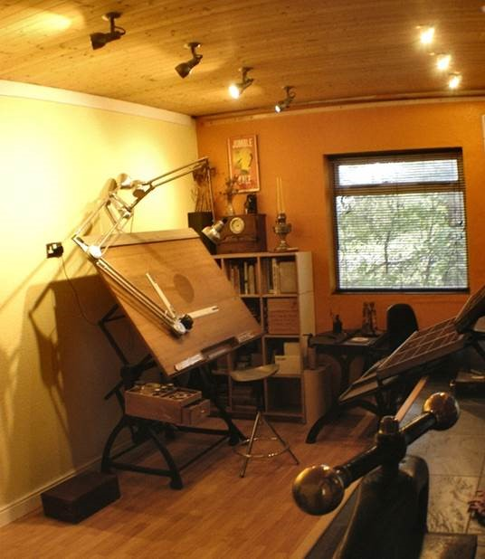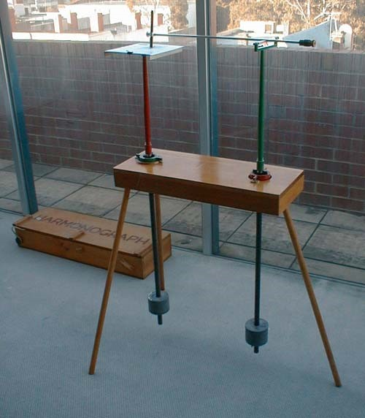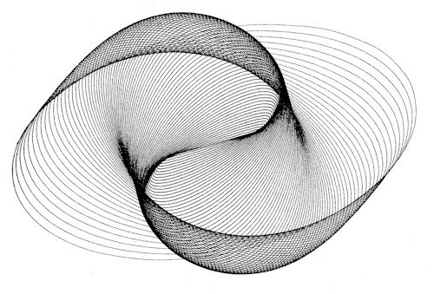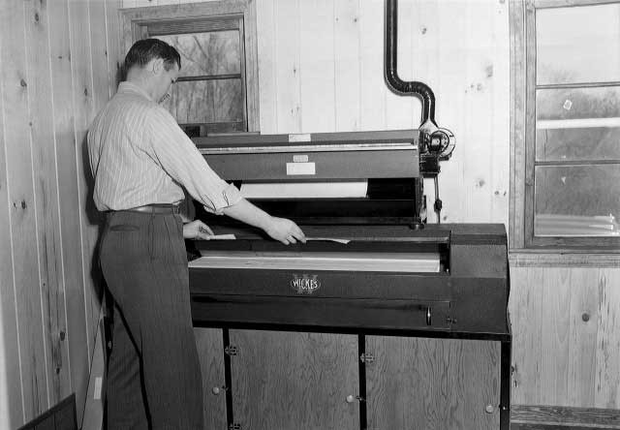
https://www.youtube.com/watch?v=HJYvc-ISrf8)
He also had an early blueprint machine ...
They used a leave-the-room, off-the-scale-bright lamp that caused acrid smoke to waft into the drawing office. The principle was that you wrapped your work around the glass tube, switched on and stood well back. We weren’t allowed to see it working - just to flap at the blue smoke. I suppose that added to its magic?
I can’t help thinking that it’s a shame that children are nowadays allowed to start school without a ‘boxwood ruler - engine-divided by 1/10ths and 1/16ths’? And it would be a better world, don’t you think, if more youngsters had Terry Clips rather than those iThingies? I lent Emily (my Japanese friend) a pencil the other day. She smiled and remarked that it was unusual now to see pencils sharpened with pen-knives. ‘Yep’, I explained. ‘That was Sam ... and then a chisel-point on your sandpaper for anything above a 2H.’
[I’ve not forgotten Sam’s bench-mounted sharpener that left the lead untouched. I just had the impression from Emily that whittling and sandpapering were enough for the time being.]” (Martin Goddard 1957-64)

The following article taken from OD & WA Newsletter No 2 - November 1994
“HARMONOGRAPH” - From Jim Austen, Staff, 1954-74
I wonder how many of you remember the “Harmonograph”, a VIth form D.O. project.
A free-swinging pendulum through a plotting table controlled an arm, at the end of which was a Biro; according to the relevant angle at which the pendulum was released, the pen wove an involved, continuous doodle on the plotting sheet, producing either scribbled rubbish or otherwise fascinating near-hissajou curves.
From a casual enquiry by a member of staff the ‘Harmo’ (if you’ll forgive the expression) was transferred to the staffroom, where, instead of receiving a cursory glance of disinterest from the intelligentsia, it became the focal point of feverish activity; any staff member seen hurtling across the car park to the staff-room during a free period was almost certainly Harmo-bent.
It proved to be the biggest time-waster next to staff-meetings (N.B. Mr. Titterington - only joking of course).
Additionally it had an insatiable appetite for scrap paper and devoured it faster than a commercial shredder; the staff room had never been so tidy, not a loose sheet anywhere.
The Harmo was quietly removed after a traumatic a.m. coffee session. All staff members present became suddenly absorbed in confidential conversations, crossword puzzles or otherwise found something to do which required their undivided attention.
The reason was due to the presence of one workaholic member of staff hunting high and low in every nook and cranny whilst asking in a plaintive voice of nobody in particular, ‘Where are they? I left them here yesterday morning; I can’t think where they could have got to; all the 5th form reports, I left them here all finished apart from my form report’.

Good to see you yesterday. It was also good that eight old boys were there to pay their last respects to Sam. In many respects that says it all, most of us had not seen him for many many years having left the school in the 1960s and yet the memory of a teacher who was liked and respected by all his pupils and had given us all so much meant that we wanted to be there to say a final farewell.
Sam was one of the greats at school, there were others but he was in the leading group. I am sure that many of us can remember learning the skills he taught from how to sharpen your 2H pencil to the wonders of isometric projection and the satisfaction of producing a drawing you could be proud of. I still find find myself doing things and remembering that Sam taught me how to do this.
Many will also remember the other contributions he made to our school lives with lunchtime activities such as the Cigarette Card Club (amazingly I still have he ones I collected!). He was also the careers master helping many to decide which route they should take to a worthwhile job or career. How many remember the car mechanics workshop he established in a basement opposite the canteen. I recall the first car we worked on was previously owned by Brian Dann, a Physics teacher who passed it to the school when its roadworthy days had passed!
Sam made a great contribution to life at the school and was liked and respected by everyone. A wonderful example of how to do the job amazingly well. I am sure he will be missed by all his friends and colleagues and indeed all those pupils for whom he did so much.
(Nigel Bourne 1956 - 1963)

I went to my first technical drawing lesson with Sam with my nice new tools, purchased by my parents according to the school list, including various grades of black pencils sharpened to points. I wasn’t the only pupil like that. To our horror, Sam went from desk to desk snapping off all our nicely formed points, with no explanation. However it had a happy ending when we were then taught how to sharpen the pencil by removing just the wood and then forming a chisel point with the sandpaper block and so produce good lines on the paper. It worked and still does. Of course modern CAD technicians may never have seen a chisel pointed pencil!
I also remember an icy morning with pupils crashing their cycles going down the hill to the school. Sam arrived very slowly in his Citroen and had to stop on the steep part of the hill - very skilfully. He open the drivers ‘suicide type ’ door, stepped out and immediately slipped on his rear and slid down the hill a short way. Great mirth from the onlooking pupils but Sam saw the funny side himself and just somehow got back in the car and no laughing pupil suffered. He had a good sense of humour.
Sam was pretty skilled with a cricket bat and delighted pupils in the summer during staff practice sessions in front of the pavilion and the not far away classroom windows. I can’t remember if it was only fellow staff members bowling or the occasional long hop from a pupil but windows were always in danger and a good hit on the building was always cheered. Much more fun than watching sports master ‘Mathews’, who was only cheered when given out.
I have to say that Sam made Technical Drawing easy, but at the same time made the pupil think for themselves, especially in homework - the ‘line in space’ was a fundamental part of his teaching. I am sure his teaching contributed a lot to my getting TD ‘A’ level in the first year of sixth form and with a career in Civil Engineering, it was with me for the rest of my life. (Brian Hyland 1956-63)

Many thanks for letting me know about Sam’s passing. I had a great deal of respect for Sam and I had really hoped to be able to attend his funeral. Unfortunately I was in hospital having all kinds of tests on Monday and Tuesday and hence was unable to attend. Nevertheless I do hope that the old boys were well represented to give Sam a good send off.
Kind regards (Ralph Smith 1956-61)

From the amount of mesages received at this sad time I think it confirms what a Gentleman and excellent Teacher that he was

“R.I.P. Sam”
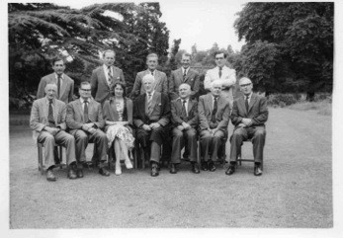
Can you name all the Staff in this Photo taken in 1961

